NRF Team Neuro 2023
Kit Order Form
FREE Fundraising Kit: All heroes who raise $100 or more will receive a free NRF Team Neuro Hero Kit which includes: Singlet or T-shirt, reusable water bottle.

Alternatively, BUY your NRF Team Neuro Kit: Purchase the above Kit at $50

Order Details:
Yes I am fundraising; Yes I plan to raise $100 (NRF Team Neuro Kit Free) Qty in team:_________
Yes I would like to Buy an NRF Team Neuro cost $50 Qty to buy:__________

T-Shirt | Women’s Sizes | Qty | Men’s Sizes | Qty
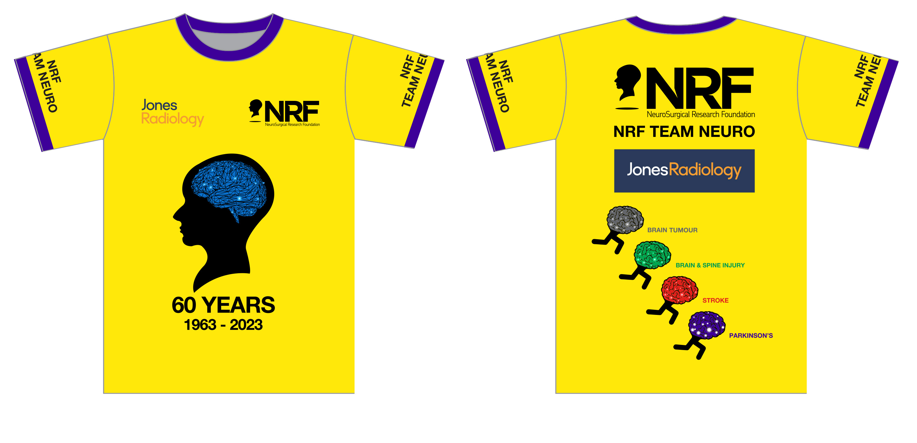 | 8 chest 82cm |  | Small chest 104cm
 | 10 chest 86cm |  | Medium chest 108cm
 | 12 chest 90cm |  | Large chest 112cm
 | 14 chest 94cm |  | XL chest 116cm
 | 16 chest 98cm |  | 2XL chest 120cm
 | 18 chest 102cm |  | 3XL chest 124cm

Singlets | Women’s Sizes | Qty | Men’s Sizes | Qty
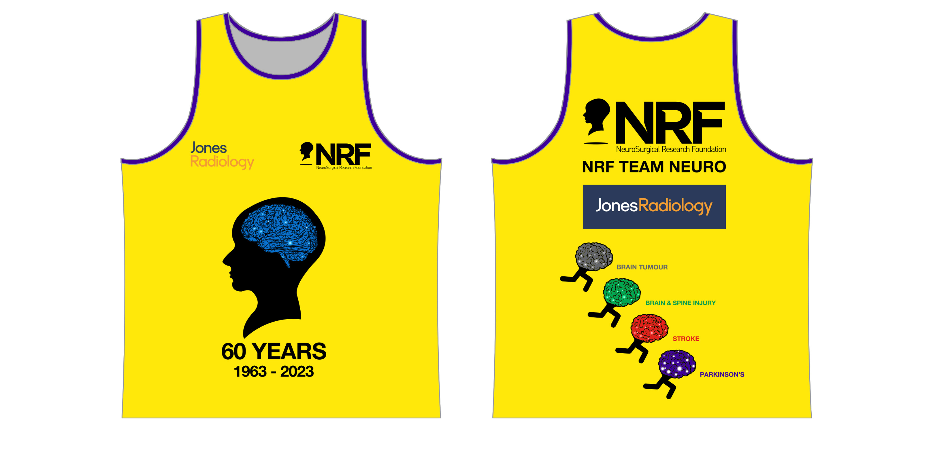 | 8 chest 74cm |  | Small chest 98cm
 | 10 chest 78cm |  | Medium chest 102cm
 | 12 chest 82cm |  | Large chest 106cm
 | 14 chest 86cm |  | XL chest 110cm
 | 16 chest 90cm

Contact details & delivery address

Name _____________________________________________________

Company Name _____________________________________________________

Address _______________________________________________________________

City / Suburb __________________________ State & PC____________

Telephone __________________________

Email ____________________________________
Payment details
Cheque payable to NeuroSurgical Research Foundation

OR Credit Card Payment: MasterCard / Visa

Credit Card No: ________/________/________/________

Expiry Date: ______/______ Amount $ ___________

Cardholder name: __________________________________

Signature: __________________________________

Post or email your order today. Post NRF PO Box 698, North Adelaide, SA 5006
Email info@nrf.com.au Enquiries 08 8371 0771 Website www.nrf.com.au

