NRF Team Neuro 2026
Kit Order Form

Become a Team Neuro Hero! All heroes who raise $100 or more will receive a FREE Team Neuro Hero Kit which includes your choice of singlet or T-shirt.

Alternatively you can purchase your NRF Team Neuro Kit for $50

Order Details:
Yes I am fundraising; Yes I plan to raise $100 (NRF Team Neuro Kit Free)
I would like to buy an NRF Team Neuro T-Shirt/Singlet cost $50
*If you are ordering for multiple people please list the total number required:______________________

T-Shirt | Women’s Sizes | Qty | Men’s Sizes | Qty
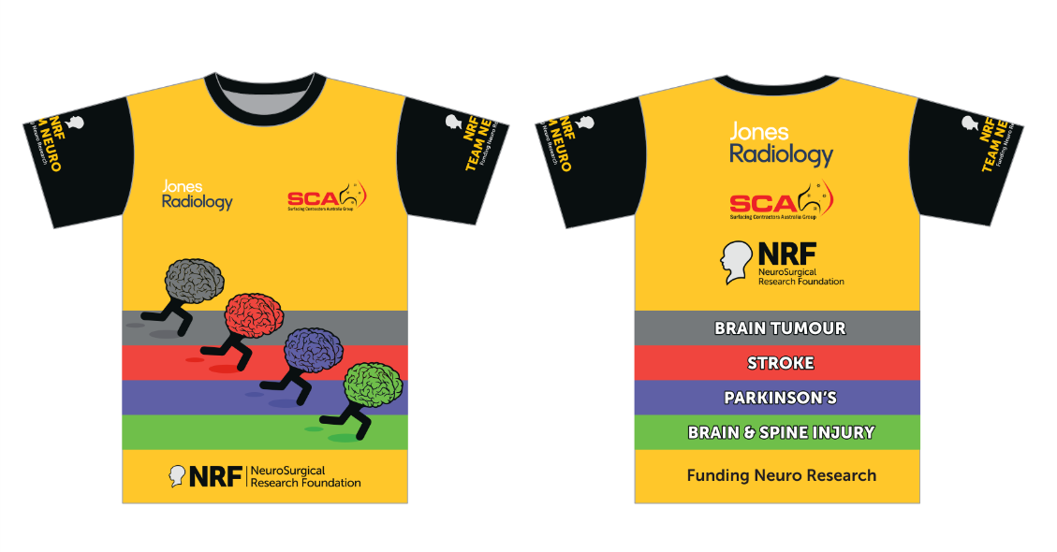 | 8 chest 82cm |  | Small chest 104cm
 | 10 chest 86cm |  | Medium chest 108cm
 | 12 chest 90cm |  | Large chest 112cm
 | 14 chest 94cm |  | XL chest 116cm
 | 16 chest 98cm |  | 2XL chest 120cm
 | 18 chest 102cm |  | 3XL chest 124cm

Singlets | Women’s Sizes | Qty | Men’s Sizes | Qty
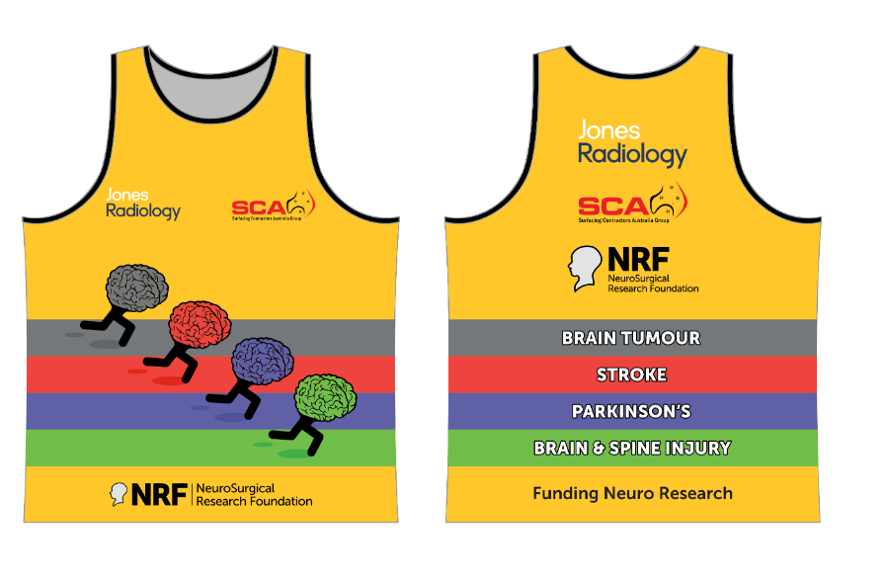 | 8 chest 74cm |  | Small chest 98cm
 | 10 chest 78cm |  | Medium chest 102cm
 | 12 chest 82cm |  | Large chest 106cm
 | 14 chest 86cm |  | XL chest 110cm

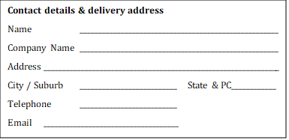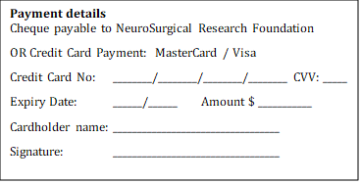
Any Questions?
Email ginta.orchard@nrf.com.au Enquiries 08 8371 0771 Website www.nrf.com.au

Still need to register?
Step 1: Register for City-Bay: https://citybay26.grassrootz.com/nrf and click Register Now
Step 2: Join NRF Team Neuro to start fundraising: https://citybay26.grassrootz.com/nrf/join

Thanks for being part of NRF Team Neuro funding life-changing neuro research.
We can't wait to see you at the finish line! Come find the NRF Tent to enjoy your complimentary refuel brunch.

